

Friday’s SKILL:

Landing



Good morning everybody.

Today your skill is Landing. Below is all the information you need.

* Activity 1 is aimed at Junior/ Senior Infants and 1st Class
* Activity 2 is aimed at 2nd/3rd / 4th class
* Activity 3 is aimed at 5th and 6th class.

Older children can definetly try all activities especially if you are working as a family. Rememember you can change each activity to make it easier or more difficult. We know you mightn’t have all the equipment, Try use what you have to fit the activity.

ALSO, your traditional sport activity today is tug of war!!

ENJOY

June 10, 2020

DPETNS

Event Explainer - Landing / Tuirlingt

**Landing**

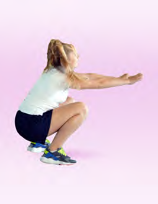The ability to land safely is a hugely important fundamental movement skill. As one of the three phases of jumping, landing should always be taught first to ensure children return safely to the ground without injury. The skill involves absorbing force over a large area, usually the legs or hands for a prolonged period of me. This force should be absorbed over as large an area or distance as possible with the joints bending to absorb the force. We use landing in a wide range of acvies, jumping to catch a ball in gaelic football, vaulting in gymnastics or from jumping off the bed. The activities used are from the Move Well Move Often booklets.

**Activity 1 - Jack be Nimble (Seáninín Sciobtha -**

Arrange the children in pairs and scatter the cones randomly around the playing area. Pupil A chants the rhyme below for pupil B who must jump off two feet over the cone (the candlestick) and attempt to land safely on the other side of the cone. Pupil B should jump over three cones while pupil A is saying the rhyme: 'Jack be nimble, Jack be quick, Jack don't land on the candlestick'. After pupil B has completed three jumps and three landings, swap roles and play again.

[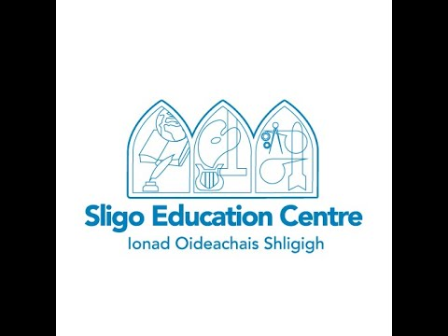](https://www.youtube.com/embed/nllViOJhowc?feature=oembed)

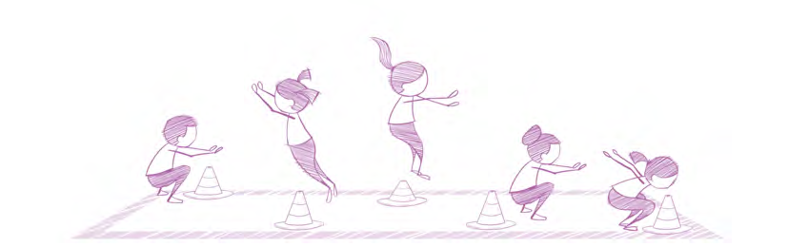**Activity 2 - Jockeys up (Marcaigh in Airde -**

Arrange children in pairs (horse and jockey) and invite them to find their own space in an open playing area. On a signal the children carry out the following movements: • Under the bridge - the jockey crawls under the horse's body. • Long way to town - the jockey jumps clockwise in a circle around the horse. • Short way to town - the jockey jumps an-clockwise around the horse. • Trade your horse - all jockeys find a new partner. Ensure partners regularly switch roles. 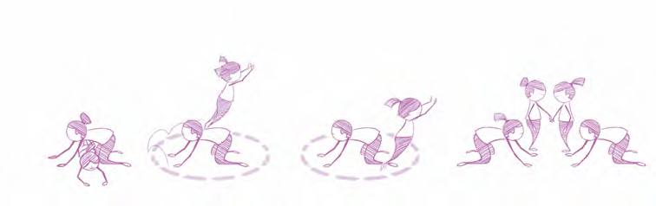

**Activity 3 - England, Ireland, Scotland, Wales**

Arrange the children in 3’s. The 2 children on the outside have the elastics/skipping rope wrapped around their ankles to start. All the children chant the rhyme;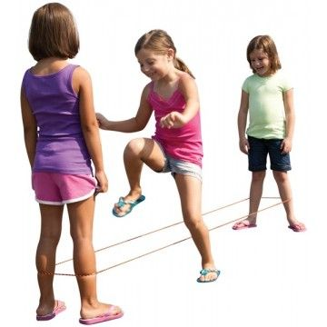

*“England, Ireland, Scotland, Wales. Inside,*

*Outside, on the rails”.* The children follow the routine as per the accompanying video. If the pupil is successful at the ankles, the elastics get moved up to the knees and then the hips. If children are working solo, they could wrap the elastics around sone chairs, a washing line, parents or older siblings’ legs.

[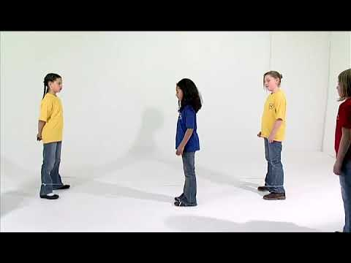](https://www.youtube.com/embed/d2EhxsozHSk?feature=oembed)

**Traditional Sport: Tug of War**

* Basic Tug of War Rules:

The game involves usage of single equipment i.e. a rope. There is a mark made in the middle of the rope. Each team stands either side of the rope.

* How to play:

The center of the rope should align with the center marked on the ground. As soon as the referee blows the whistle, each team can start pulling the rope into their territory. The objective of the game is for each team to pull the rope along with the members of opposition team to their side. As soon as the team cross the center mark and cross into the other teams area, the other team wins.

[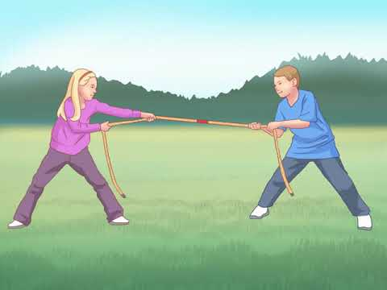](https://www.youtube.com/embed/tq6dkPfBKAE?feature=oembed)

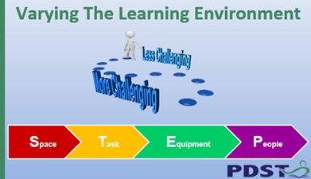It is possible to increase or decrease the level of challenge in any task using STEP. Increase or decrease the space or distance, amend the task, change the equipment or add involve or change the people playing the game.