2 stars and a wish - **Kicking**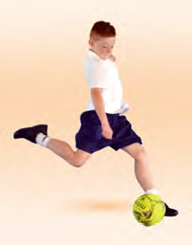

What did you like about this event?

What would you change?

