

MONDAY SKILL:

Running



GOOD MORNING EVERYBODY.

TODAY YOUR SKILL IS **RUNNING**.

BELOW IS ALL THE INFORMATION YOU NEED.

* ACTIVITY 1 IS AIMED AT JUNIOR/ SENIOR INFANTS AND 1ST CLASS
* ACTIVITY 2 IS AIMED AT 2ND/3RD / 4TH CLASS
* ACTIVITY 3 IS AIMED AT 5TH AND 6TH CLASS.

OLDER CHILDREN CAN TRY ALL ACTIVITIES, ESPECIALLY IF YOU ARE WORKING AS A FAMILY.

YOU CAN CHANGE EACH ACTIVITY TO MAKE IT EASIER OR MORE DIFFICULT.  WE KNOW YOU MIGHT NOT HAVE ALL THE EQUIPMENT, USE WHAT YOU HAVE TO FIT THE ACTIVITY.

YOUR TRADITIONAL SPORT ACTIVITY TO TRY TODAY IS **SACK RACE**!!

TRY YOUR BEST AND ENJOY THE CHALLENGE!

Event Explainer - Running / Rith

**Running** 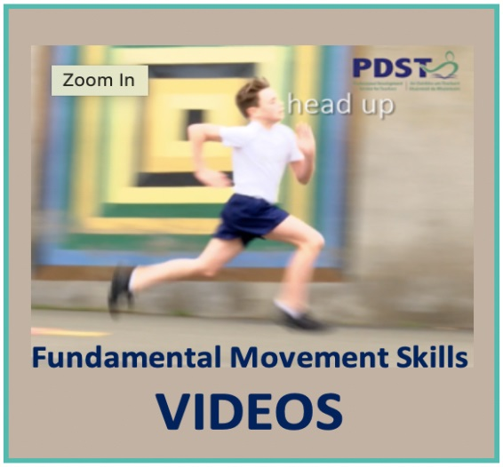

-Running is similar to walking except there is a moment of suspension called the flight phase when both feet are simultaneously off the ground.

-The skill of running includes jogging, sprinting, dodging and evading.

-The ability to run is essential to perform a wide range of activities in both everyday life and sporting contexts.

-Whether it is sprinting in a race or running for pleasure, chasing a football or trying to catch a butterfly, it is essential that everyone develops a proficient running technique.

**Teach Mechanics for Running Movement**

Step 1: legs together

Step 2: legs shoulder width apart

Step 3: ‘Sl-iii-de’ - slide one leg back still shoulder width apart, both feet facing forward

Step 4: ‘Sink’ - knees bent, back straight (drop your bottom)

Step 5: ‘Arms’ - 90 degree elbows, opposite arm to leg forward

Step 6: ‘Roll’ – roll onto balls of feet so heels off ground and balanced

Step 7: ‘GO’ – move forward on balls of feet, increasing stride after 3 steps –

-Mark a running distance of 15-20m with flat spot.

-Ask pupils to increase stride as they come out of third step.

-As they approach the spot they need to shorten stride for stopping.

-Push off from spot with lead leg and return.

-Repeat making sure each ‘step’ is followed.

**Activity 1 - Traffic Lights**

**(Soilse Tráchta)**

**Description of Activity**

-Invite children to find a space in a large open playing area, where they are not in contact with anyone else.

-On a signal, pupils move around the playing area in response to the following commands. -Turn it into a game of moving statues to develop.

• **Red:** stop

• **Amber:** walk

• **Green:** run

See an example of how to play here:

[](https://www.youtube.com/embed/Uj9_pdx_vEA?feature=oembed)

**Activity 2 - Rock, Paper, Scissors (Carraige - Páipéir - Siosúir)**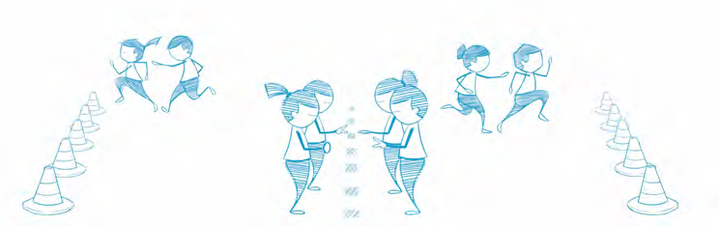

**Description of Activity**

-Arrange pupils in pairs, standing one metre apart and facing each other.

-All pairs line up along a centre line with a safety line positioned twenty metres behind both sets of pupils.

-Each pair begins by performing a rock-paper-scissors routine. A rock is a closed fist, paper is a flat hand, and scissors are the index and middle fingers in a cutting position. **Paper always covers rock, rock breaks scissors, and scissors cut paper.**

-To determine a winner, pupils count to three and form a rock, paper, or scissors.

-The winning pupil then chases their partner toward their safety line, attempting to tag them before they are safe.

-Line up again and repeat the activity.

See an example of how to play here:

[](https://www.youtube.com/embed/oYCPKHFvveM?feature=oembed)

**Activity 3 – Make the Face –**

**(Déan an aghaidh )**

**Aim**

Use the equipment indicated or any similar household equipment and map key to create the Funny Face accurately using information on the map.

**Organisation**

-Set up equipment as shown. Put out extra if available to allow for mistakes.

-Explain to children the concept of the word ‘symbol’.

-Pupil is given a Funny Face map, runs to their pile of equipment, selects the right piece for No 1 on their map, then places it in appropriate place in their Funny Face hoop / rope.

-The pupil then runs back and hands map to other person.

-Continue till Funny Face is complete.

See an example of the activity here

[](https://www.youtube.com/embed/wukOb2owkWY?feature=oembed)

There is a full range of faces available free at the link below.

(<https://www.britishorienteering.org.uk/images/uploaded/downloads/schools_tri_o_resources.pdf> )

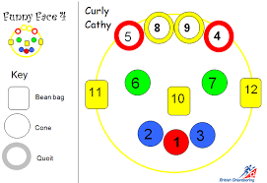

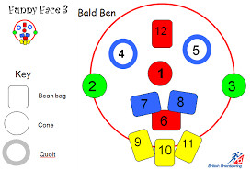

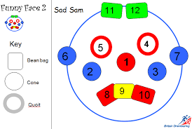

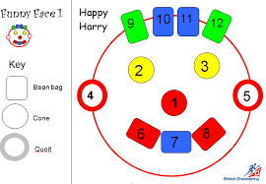

**Traditional Activity: Sack Race**

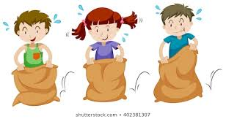

There are numerous variations to sack racing rules. Here are just a few suggestions for you—but half of the fun of these games is putting your own spin on the rules! So get out there and be creative!

**Individual Sack Race:**

To play you need one sack for each individual participant. You could use a pillow case, bin bag, black sack or potato sack. The more people racing, the more fun it is.

* Participants will run to the sack, put both feet in and begin hopping toward the finish line.
* Contestants must keep both feet in sack and at least one hand on the sack at all times.
* The sack must remain as close to the waist as possible and should not fall below the knees.
* The first racer to the finish line wins.

**Relay Race:**

To play you need one sack for each participant or team. The more people racing, the more fun it is.

* Each player puts both legs into sack and hops around a cone, or some marked point, and back, tagging the next person in line.
* Then, the next person in line gets into the sack and repeats the once-around the cone course.
* The first team to the finish line wins.

Note: The relay race can be done with individual participants or two-person teams. The two-person teams can fit both team members in the same sack, or by placing one leg each inside for the “Three-Legged Race.”

**VARIATIONS:**

To add a twist to any of the above races, try some of this:

* Add obstacles to the course (make sure they are safe, though).

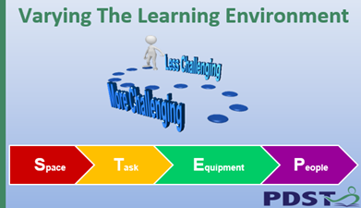

It is possible to increase or decrease the level of challenge in any task using STEP. Increase or decrease the space or distance, amend the task, change the equipment or add involve or change the people playing the game.