Tuesday
Daily Skill Work: Throwing
GOOD MORNING EVERYBODY.

BELOW IS ALL THE INFORMATION YOU NEED.

- ACTIVITY 1 IS AIMED AT JUNIOR/ SENIOR INFANTS AND 1ST CLASS
- ACTIVITY 2 IS AIMED AT 2ND/3RD / 4TH CLASS
- ACTIVITY 3 IS AIMED AT 5TH AND 6TH CLASS.

OLDER CHILDREN CAN TRY ALL ACTIVITIES, ESPECIALLY IF YOU ARE WORKING AS A FAMILY.
YOU CAN CHANGE EACH ACTIVITY TO MAKE IT EASIER OR MORE DIFFICULT. WE KNOW YOU MIGHT NOT HAVE ALL THE EQUIPMENT, USE WHAT YOU HAVE TO FIT THE ACTIVITY.

YOUR TRADITIONAL SPORT ACTIVITY TO TRY TODAY IS Welly Toss!!

TRY YOUR BEST AND ENJOY THE CHALLENGE!

The manipulative skill of throwing goes
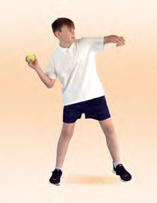
hand in hand with catching, and involves propelling an object away from the body. This important fundamental movement skill has many variations, including the underhand throw, overhand throw, roll and the two handed throw. This resource focuses on the overhand throw, as many of its principles may be applied to the other variations. Concepts such as weight transference, generating force, developing a swinging moon and momentum are all important when learning to throw. The skill is used in a wide range of activities such as throwing a javelin, serving in volleyball, chest pass in basketball, rolling in lawn bowls, pitching in baseball or throwing a paper airplane. The activities used are from the Move Well Move Often booklets. Please click below.

Activity 1 - Knock ‘em Down Pinball (Leag iad leis Bpionnliathróid - Gluais go maith, Gluais go minic - Leabhar 1 lth. 163)
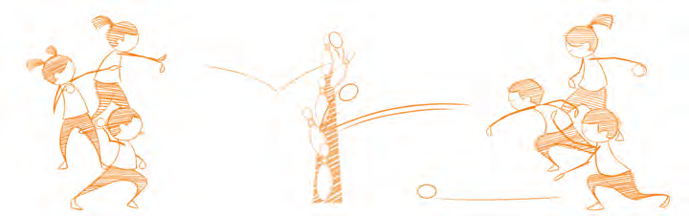
Arrange pupils in groups of four or pupils can play in pairs or singly. Pupils line up fifteen metres apart, either side of a line of skittle targets as shown. Pupils could also use cans of Beans or empty cereal boxes. Groups take turns to roll a ball, trying to knock over a target in the middle. If a pupil successfully knocks over a skittle, they can claim this skittle and bring it over to their side. Continue playing until all of the skittles have been claimed.

Watch how to play the game here:

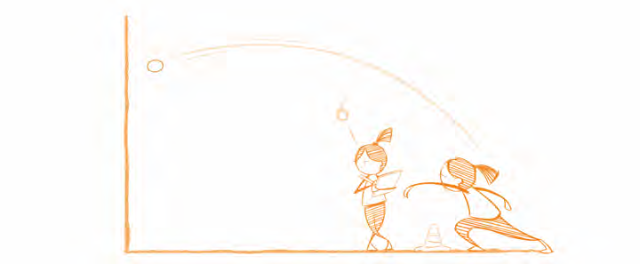
Activity 2 - Tennis ball Challenge (Dúshlán na Liathróide Leadóige - Gluais go maith, Gluais go minic - Leabhar 2 lth. 159)

Pupils work in pairs, one throwing and the other counting. The aim is to throw the ball against the wall and catch it again as many times as possible in thirty seconds. For safety reasons ensure that groups are spaced at least three metres apart.

Watch how to play the game here:

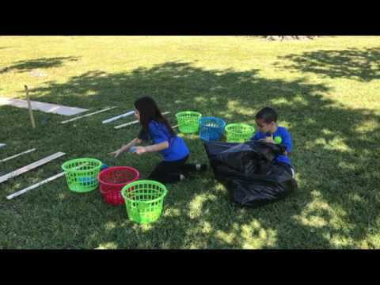

Activity 3 - Bowling (Babhláil - Gluais go maith, Gluais go minic - Leabhar 3 lth. 145)

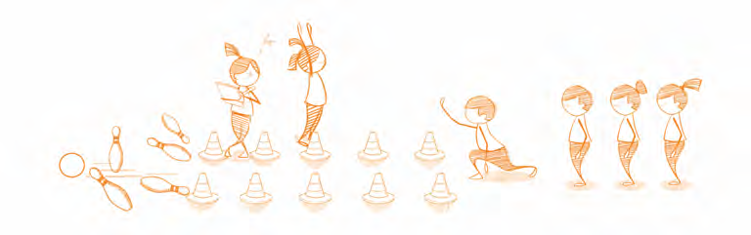
Use cones to set up a bowling lane approximately five metres in length for each group. At the end of the bowling lane place five skittles as targets. Each bowler has three balls to knock over as many skittles as possible. All bowlers take a turn and then Replaced the knocked skittles. Keep your score. The pupil that knock over the most skittles wins. Increase difficulty by increase the distance between the thrower and the skittles or decreasing the width of the lane.

Watch how to play the game here:

Traditional Sport: Welly Toss

DESCRIPTION
Throwing the welly is not as easy as it first appears. The event is intended to be held out of doors using a large area for safety.
AIM
To throw the welly as far as possible in a forward direction.

TECHNIQUE
The welly can be thrown standing or with a turn, but an under arm throw normally proves easier.

How to throw
  - The welly must be released in the direction of the throw.
  - The participant must throw from behind the throwing line.
  - Keep other participants behind the throwing line and clear of the thrower.

Watch how it is done:
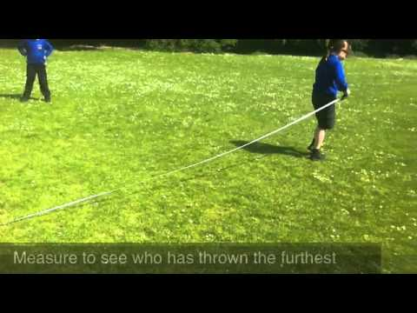

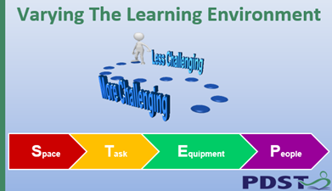

It is possible to increase or decrease the level of challenge in any task using STEP. Increase or decrease the space or distance, amend the task, change the equipment or add involve or change the people playing the game.

