WEDNESDAY SKILL
KICKING
Good morning everybody.
Today your skill is KICKING. Below is all the information you need.

- Activity 1 is aimed at the junior end of the school (J.I – 2nd)
- Activities 2 & 3 are aimed at the senior end of the school (3rd – 6th)

Children from all classes are welcome to try all three activities. Rememember you can change each activity to make it easier or more difficult. We know you mightn’t have all the equipment, Try use what you have to fit the activity.
ALSO, your traditional sport activity today is the 3-legged Race!!
ENJOY!

DPETNS
Event Explainer - Kicking / Ciceáil

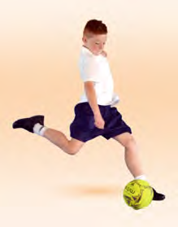

Kicking
Striking with the foot or kicking is a manipulative skill synonymous with many sporting activities in Ireland. Kicking a moving object, foot dribbling, and trapping are all components of striking with the foot. This resource pack will initially address striking a stationary object as it is the easiest to become proficient in, and then can be applied to many activities and modified games. The activities used are from the Move Well Move Often booklets.

Activity 1 - Through the Gate
Arrange pupils in pairs with one ball per pair. Each pupil stands on a spot facing their partner who is also standing on a spot ten metres away. Set up a gate between each pair using two cones. Pupil A attempts to kick the ball to pupil B through the gate. One point is awarded for each pupil that successfully kicks the ball through the gate. Single pupils could play the game off a wall. Increase the distance to increase difficulty. Add some targets.

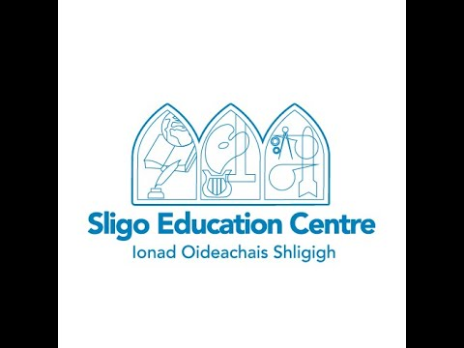

Activity 2 – Kick to Score (Ciceáil le haghaidh scóir)
Draw or stick target areas at various heights on a wall. Points should be placed in the centre of each target from one to five. Arrange pupils in groups of three or four. Pupils are given a score to achieve, e.g. ten. Groups must hit the targets on the wall to achieve that score.

Activity 3 – Rebound Ball (Peil Aisphreabtha)
Arrange pupils in groups of four with one cone/skittle and one football each. The first pupil places their cone three to five metres from the wall within their designated playing area. This pupil then places their ball next to the skittle and kicks it, aiming to hit the skittle on the rebound. If the cone is hit, the cone is then moved one metre further away from the wall. A goal line can be set ten metres from the rebound wall. A goal is scored when a pupil has successfully progressed the cone, metre by metre, back across the goal line.
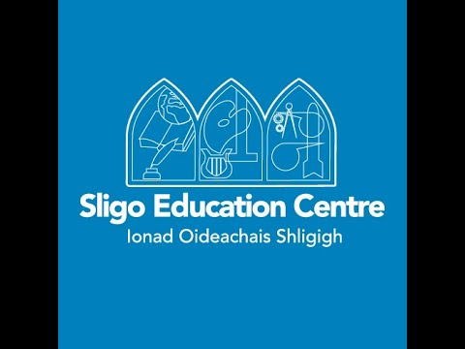

Adjusting Activities – STEP
It is possible to increase or decrease the level of challenge in any task using STEP. Increase or decrease the space or distance, amend the task, change the equipment, or add involve or change the people playing the game.
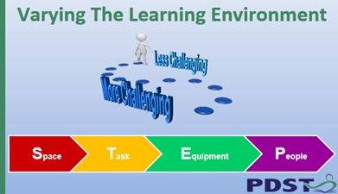

Traditional Sport: 3-Legged Race
The 3-Legged Race is a running event which involves a pair of participants running, with the left leg of one runner attached to the right leg of their partner runner. The objective is to cross the finish line before the other runners, or to time yourselves and try clock the quickest time.
